Chapter X
Writing Container-Managed Persistent Entity Beans
In the previous chapters, we learned the basics of entity beans, and also wrote a bean-managed persistent entity bean representing a bank account. In this chapter, we'll see how things change when we move to a container-managed persistent (CMP) model. With container-managed persistence, you don't implement any persistence logic (such as JDBC or SQL/J) in the entity bean itself—rather, the EJB container performs storage operations for you. As you will see, this greatly simplifies bean development.
Features of CMP entity beans
We'll kick things off by looking at the major differences between container-managed persistence (CMP) and bean-managed persistence (BMP). Before reading this, you should be familiar with the entity bean concepts we covered in the last two chapters.
CMP entity beans are subclassed
Imagine that you are a bean provider who writes beans that others will consume, such as an independent software vendor (ISV) or a department that writes components that other departments reuse. You need to write your beans to be database-independent because who knows what storage the consumers of your bean will want to use. You certainly don't want to allow the consumers of your beans to access your source code, because it violates your intellectual property rights, and furthermore, if they modify the code, then it makes future upgrades to new versions of your components difficult.
To answer this need, the authors of the EJB specification have tried to make container-managed persistence have a clean separation between an entity bean and it's persistent representation. That is, a separation between the data logic methods (such as logic in your entity bean to add two fields together) and the JDBC. The reason why having this separation is valuable is because you can modify the persistent representation of an entity bean (such as changing from a relational database to an object database) without affecting the entity bean logic. This is a crucial feature for bean providers.
To achieve this clean separation, you write your container-managed persistent entity bean class to be devoid of any JDBC or other persistence logic. The container then generates the JDBC by subclassing your entity bean class. The generated subclass inherits from your entity bean class. Thus all container-managed persistent entity beans are each broken up into two classes: the superclass (which you write, and contains the entity bean data logic) and the subclass (which the container generates, and contains the persistence logic). By having these two classes we have achieved a very clean separation of entity bean logic and persistent representation. The actual entity bean is a combination of the superclass and the subclass. This is shown in Figure X.X.
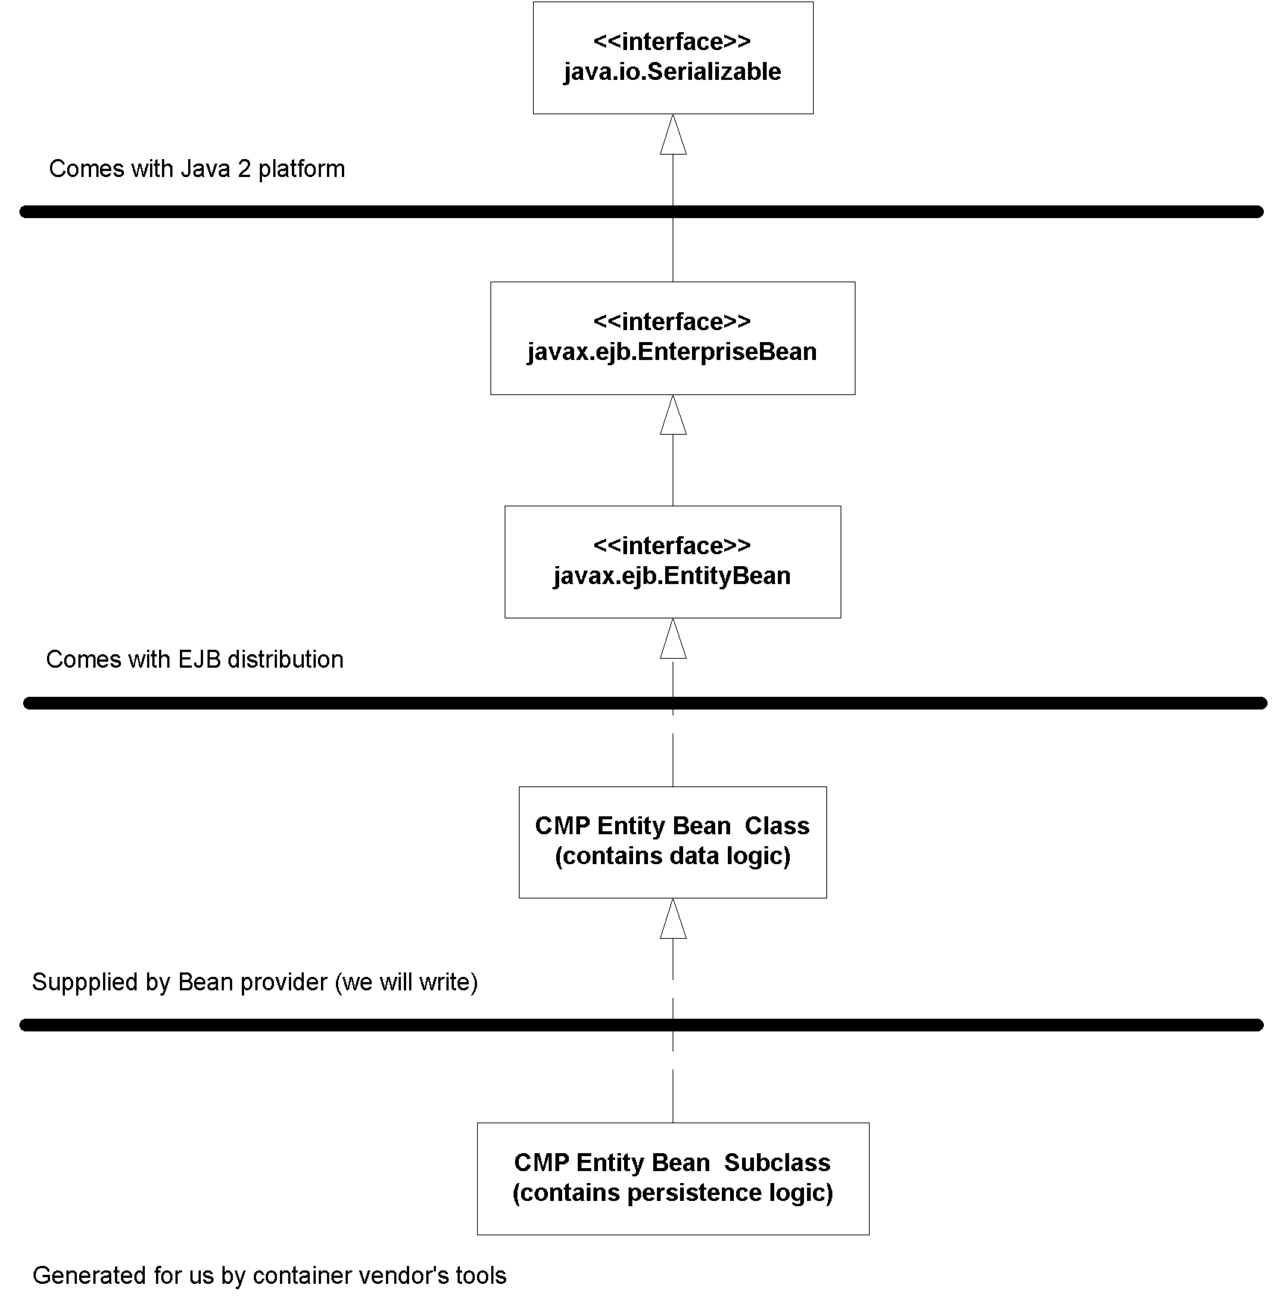
Figure X.X The subclassing concept
NOTE
Entity beans are very different between EJB 1.1 and EJB 2.0. EJB 1.1 entity beans do not require the use of subclassing. EJB 2.0 containers must support both the old EJB 1.1 style and the new EJB 2.0 style of entity beans. For an example of an EJB 1.1 entity bean, see the accompanying source code with this book.
CMP entity beans have no declared fields
Another issue with container-managed persistence is that the container might have additional fields or logic that are part of your persistent representation, but are container-specific. As a bean developer, you should be oblivious to this information. Here are two examples:
- A container might keep around a bit vector that tracks which of your entity bean fields have been modified (that is, are dirty) and need to be written to storage. Then when your bean is stored, the container would only persist the part of your bean that has changed.
- Your bean might hold references to other beans. The container must preserve referential integrity of those relationships, as described in Chapter X.
Thus, since every container has its own proprietary way of dealing with your persistent representation, your persistent fields are kept in the subclass, not the superclass. This is another paradigm shift with container-managed persistent entity beans--you don't declare any persistent fields in your bean. For example, take a look at the following is a snippet of code from a bean-managed persistent bank account entity bean class that we wrote in Chapter X:
// BMP
public class AccountBean implements EntityBean {
public String accountID; // PK
public String ownerName;
public double balance;

...methods...
}
With container-managed persistence, the fields are not present. Rather, the container generates your persistent fields in the subclass. For example, the following subclass might be generated from the container tools:
// CMP Subclass
public class AccountBeanSubClass extends AccountBean {
public String accountID; // PK
public String ownerName;
public double balance;

...methods...
}
CMP get/set methods are defined in the subclass
One corollary of the subclass paradigm is that the subclass, not the superclass, implements the get/set methods. For example, here is that bean-managed persistent bank account again:
// BMP
public class AccountBean implements EntityBean {
public String accountID; // PK
public String ownerName;
public double balance;

public String getOwnerName() {
return ownerName;
}

public void setOwnerName(String ownerName) {
this.ownerName = ownerName;
}

...other methods...
}
With container-managed persistence, the get/set methods would appear in the subclass, since that is where the fields exist, and thus that is the only place that they can be accessed. Here is what the container-generated subclass looks like:
// CMP subclass
public class AccountBeanSubClass extends AccountBean {
public String accountID; // PK
public String ownerName;
public double balance;

public String getOwnerName() {
return ownerName;
}

public void setOwnerName(String ownerName) {
this.ownerName = ownerName;
}

...other methods...
}
So what does the superclass look like then? Well, realize that while the superclass cannot possibly implement the get/set methods since the superclass doesn't have access to the fields. However, the superclass does need to call those get/set methods. For example, let's say you have a shopping cart entity bean that contains a subtotal field and a taxes field on the contents in the shopping cart. One useful method you might want to write is a getTotal() method which returns the subtotal+taxes. That's more than just a simple get/set method, and thus it cannot be generated automatically for you by the container in the subclass. Therefore you need to write that method in the superclass yourself. But what would that getTotal() method look like? With bean-managed persistence, it could look like this:
// BMP
public class CartBean implements EntityBean {
...

public float getTotal() {
return this.getSubtotal() + this.getTaxes();
}

...
}
The above code works well with bean-managed persistence, because we can define the getSubtotal() and getTaxes() methods. But with container-managed persistence, the simple get/set methods getSubtotal() and getTaxes() are defined in the subclass, so how can we access those get/set methods? The answer is to declare your get/set methods as abstract methods in the superclass. An abstract method is a method whose implementation is deferred to a subclass. Yet by defining a method as abstract you can call it from the superclass. For example, a CMP shopping cart bean would look like this:
// CMP superclass
public abstract class CartBean implements EntityBean {
// no fields

// abstract get/set methods
public abstract float getSubTotal();
public abstract float getTaxes();

// other business methods
public float getTotal() {
return this.getSubtotal() + this.getTaxes();
}

// EJB required methods follow
}
The subclass for this bean is the subclass we showed earlier. As another example, a CMP account bean would look like this:
// CMP superclass
public abstract class AccountBean implements EntityBean {
// no fields

// abstract get/set methods
public abstract String getOwnerName();
public abstract void setOwnerName(String ownerName);

// EJB required methods follow
}
CMP entity beans have an abstract persistence schema
So far, we've discussed how the container generates JDBC code, persistent fields, and get/set method implementations. One lurking question here is how does it know what to generate? The answer is you declare it in your bean's deployment descriptors. The EJB container inspects the deployment descriptors to figure out what to generate. This definition of how you'd like to be persisted is called your abstract persistence schema. For example, here is a snippet from an Account deployment descriptor:
...
<cmp-version>2.x</cmp-version>

<abstract-schema-name>AccountBean</abstract-schema-name>

<cmp-field>
<field-name>accountID</field-name>
</cmp-field>

<cmp-field>
<field-name>ownerName</field-name>
</cmp-field>

<cmp-field>
<field-name>balance</field-name>
</cmp-field>

<primkey-field>accountID</primkey-field>
...
Here is a brief explanation of this deployment descriptor snippet:
- The cmp-version must be 2.x if you want to take advantage of EJB 2.0 CMP. If you are on the older EJB 1.1 specification, you should define this to be 1.x. For an example of an EJB 1.1 CMP bean, see the book's accompanying source code.
- The abstract-schema-name is the nickname you want to give this abstract persistence schema. It can have any value you want. We recommend naming it after your bean. Later we will reference this nickname when doing queries.
- The cmp-field elements are your container-managed persistent fields. Each field is a persistent field which the container will generate in the subclass. The names of these fields must match the names of your abstract get/set methods, except the first letter is not capitalized. For example, if your abstract get/set methods are getOwnerName() and setOwnerName() then your cmp-field should be called ownerName. The container will derive the types of these fields from the get/set methods as well.
We will see a complete example of an abstract persistence schema later in this chapter.
CMP entity beans have a query language
The another piece of our CMP entity bean puzzle is addressing how to query entity beans. One large difference between entity beans and session beans is that entity beans can be found in addition to created from scratch. This is because the database data may already exist, and a Java object can be reconstructed to represent that data. To enable clients of your bean to find you, you must define finder methods. For example, in BMP you'd define this method in your home interface:
public Account findBigAccounts(int minimum);
The home object would delegate this call to your bean, whose implementation would be:
public AccountPK ejbFindBigAccounts(int minimum) {
// Perform JDBC, and return primary keys for
// all accounts whose balance is greater
// than the minimum passed in
}
With CMP, the container generates this JDBC for us. However, we need a way to tell the container how to generate that JDBC, because the container can't magically know what "find big accounts" means. We would like a way to specify how to generate the persistence code in a portable way so that we don't have to completely rewrite the definitions of these finder methods every time we port our bean to a new container.
The solution to this challenge is the EJB Query Language or EJB-QL. EJB-QL is an object-oriented SQL-like syntax for querying entity beans. It contains a SELECT clause, a FROM clause, and an optional WHERE clause. You write the EJB-QL code in the deployment descriptor, and the container should be able to generate the corresponding database logic (such as SQL), perhaps with some help from the container tools. This is a similar concept to the Object Query Language (OQL) described in Chapter X.
Here is an example of EJB-QL that finds all accounts:
SELECT OBJECT(a)
FROM Account AS a
WHERE a.accountID IS NOT NULL
If you are using a relational database, then at deployment time, and with the help of the container's tools that you use, the container will inspect this code and generate the appropriate JDBC code.
Here is another example which satisfies the findBigAccounts() home method:
SELECT OBJECT(a)
FROM Account AS a
WHERE a.balance > ?1
In the above code, ?1 means the first parameter passed in, which in this case is the variable minimum.
We will see more EJB-QL in the example later in this chapter. There is also a complete reference in Appendix X.
Note
Not all fields within the bean have to be managed by the container. You might be pulling data manually from a secondary source, or you might have calculated fields. The EJB container will automatically notify your bean class during persistent operations, allowing you to manage these fields.
In general, containers are not responsible for persisting any data in the super class, such as entity context references or environment naming contexts used for JNDI lookups. You would never want to store these persistently as container-managed fields because they contain runtime EJB-specific information, and they do not represent persistent business data.
The complete process of developing and deploying a CMP entity bean is shown in Figure X.X
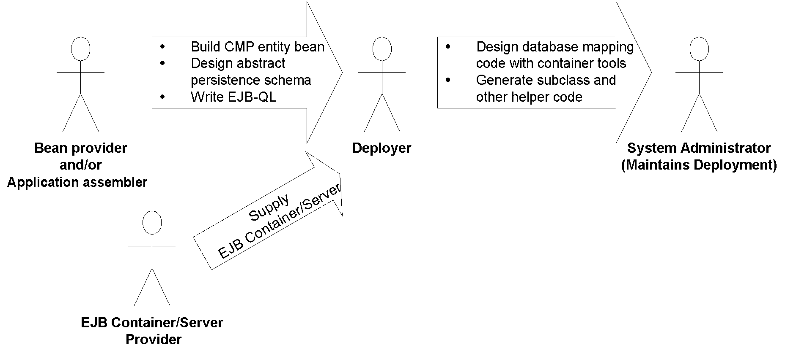
Figure X.X the process of developing and deploying a CMP entity bean
CMP entity beans can have ejbSelect() methods
The final major difference between BMP and CMP entity beans is that CMP entity beans can have special ejbSelect() methods. An ejbSelect() method is a query method (like a finder method) but is not directly exposed to the client in the home interface or component interface. Rather, ejbSelect() is used internally within an entity bean as a helper method to access a storage. ejbSelect() is useful when you have entity beans in relationships with external data, such as other entity beans. We will see ejbSelect() in action when we discuss complex persistence in Chapter X.
Tip
As you may have noticed by now, the major differences between CMP and BMP lie in the entity bean class and the deployment descriptors. The remote interface, local interface, home interface, local home interface, and primary key class remain basically the same. This means it is possible to switch between CMP and BMP without changing the clients who call your beans, which is a nice side effect.
Implementation Guidelines for Container-Managed Persistence
Now that we've explored CMP entity beans in theory, let's see how to build CMP entity beans. The method implementations of your BMP entity beans should be different for CMP. No longer are you controlling the routine persistent operations of your beans, and so many of the methods can be left empty—the container will do it for you. Table X.X is a summary of what you should implement in each method, assuming your entity bean's persistence is container managed. Take a quick glance at the chart for now. As you can see from the table, many of the database-intensive operations have been reduced in scope significantly. You should refer back to the chart when reading through the code in this chapter or when programming your own entity bean classes. The order of methods listed very roughly models the flow of control of an entity bean instance's life cycle that we saw at the end of Chapter X.
Table X.X Descriptions and Implementation Guidelines for Container-Managed Persistent Entities
Method |  | Explanation | Typical implementation
setEntityContext()  (same as bean-managed persistence) |  | If the container wants to increase its pool size of bean instances, it will instantiate a new entity bean instance. Following this, the container calls the instance's setEntityContext(). This method associates a bean with context information—information about the bean's environment. Once this method is called, the bean can access information about its environment. | Stick the entity context somewhere, such as in a member variable. You can then access the context later to acquire environment information, such as security information, from the container.  You should also request any resources your instance will need regardless of what data the bean represents.  The bean is now in a pool, does not have any specific database data inside of it, and is not bound to any particular EJB object.
ejbFind<…>(<…>)  (new for container-managed persistence) |  | You do not write finder methods for container-managed beans. The EJB container will handle all issues relating to finding data for you. But how does the EJB container know what kinds of finder methods you want in your bean? After all, there are an infinite variety of ways to find data in a database. The answer is that your EJB container ships with tools for this purpose. You use EJB-QL and the container tools to tell the container what logic to execute when the client performs a finder method on the home object. | You should not implement these methods for container-managed persistent entity beans.
ejbSelect<…>(<…>)  (new for container-managed persistence) |  | ejbSelect() methods are helper methods that perform queries internally by your bean, but are not accessible to clients of your bean. | Define this method as abstract. Then write EJB-QL in the deployment descriptor to setup the query.
ejbHome<...>(<...>)  (new for container-managed persistence) | Sometimes you need methods on an entity bean that are not specific to any given data instance (or row). For example, counting up the total number of accounts in a table. You can write ejbHome methods to perform these operations. The ejbHome methods are special business methods because they are called from a bean in the pool, before the bean is associated with any specific data. Clients call these methods from the home interface or local home interface. |  | Perform your 'global' operations, such as counting up the rows in a database, and returning the results to the client. The fast-and-easy way to achieve this is to use JDBC. The cleaner (but lower-performing way if you're not careful) is to call ejbSelect() and perhaps other entity bean methods.
ejbCreate(<…>)  (new for container-managed persistence)  Note: You do not need to write any ejbCreate() methods if you don't want EJB clients to be able to create new database data. Some systems may allow creation of data to occur via direct database inserts through batch files or other means. |  | When a client calls create() on a home object, the container then calls ejbCreate() on a pooled bean instance. ejbCreate() methods are responsible for creating new database data and initializing your bean. | Do not create database data in this method. Rather, simply check that the client parameters are correct, and set your container-managed fields to the parameters passed in. After the EJB container calls your ejbCreate() method, it will extract the container-managed fields from your bean and create the database representation of the data for you.  If you'll recall, with bean-managed persistence, your ejbCreate() method returns a primary key class to the container. With container-managed persistence, you don't need to return a primary key class. The EJB container can simply extract data from your public fields and create a primary key object by itself.  Your entity bean instance is then no longer in the pool—it now has specific database data inside it. The container will bind your instance to a particular EJB objects.
ejbPostCreate(<…>)  (new for container-managed persistence) |  | There is one ejbPostCreate(...) for each ejbCreate(...). Each pair has the same parameters.  The container calls your bean instance's ejbPostCreate(...) method following ejbCreate(...). | The container calls ejbPostCreate() after it has associated your bean instance with an EJB object. You can now complete your initialization, by doing anything you need to that requires that EJB object, such as passing your bean's EJB object reference to other beans.  You might also use this method to reset certain transaction-related parameters—for example, you could keep a data status flag in the bean to indicate whether a field has been changed. Because the bean instance may have been used before, these fields might have dirty data.  Note: By now the EJB container will have created your primary key object, so you can now retrieve it and use it.
ejbActivate()  (same as bean-managed persistence) |  | When a client calls a business method on an EJB object, but there is no entity bean instance bound to the EJB object, the container needs to take a bean from the pool and transition it into a ready state. This is called activation. On activation, the ejbActivate() method is called by the EJB container.  Note: ejbActivate() is never called during a transaction. | Acquire any bean-specific resources, such as socket connections, that your bean needs to service a particular client when it's moved into the ready state.
ejbLoad()  (new for container-Managed Persistence) |  | The EJB container calls this to load database data into your bean instance, based on the current transactional state. | Do not read data from the database in this method. Rather, the EJB container will read in data from the database for you automatically right before calling your ejbLoad() method. It does this by setting your container-managed fields to the data it reads from the database.  In this method, you should perform any utilities you need to work with the read-in data, such as decompressing a text field.
ejbStore()  (new for container-managed persistence) |  | The EJB container calls this to update the database to the new values of your in-memory fields, thus synchronizing the database. The current transactional state dictates when this method is called. Also, this method is called during passivation, directly before ejbPassivate(). | Do not update the database in this method. Rather, the EJB container will update the database for you automatically right after calling your ejbStore() method. It does this by extracting your container-managed fields and writing them to the database.  In this method, you should prepare your container-managed fields to be written to the database. For example, you can compress the text of your fields if necessary.
ejbPassivate()  (same as bean-managed persistence) |  | The EJB container will call this method when it wants to return your entity bean to the pool. This is called passivation and is the opposite of activation. On passivation, the ejbPassivate() method is called by the EJB container.  Note: ejbPassivate() is never called during a transaction. | Release any resources, such as socket connections, that you allocated in ejbActivate() and that your Bean was holding during the ready state for a particular client.
ejbRemove()  (new for container-managed persistence) |  | The client calls the home object's remove() method to destroy database data remove(), then calls your ejbRemove(). Note that this does not destroy the Java Object because the object can be pooled and reused for different data. | Do not destroy database data in this method. Rather, simply perform any operations that must be done before the data in the database is destroyed. The EJB container will destroy the data for you right after ejbRemove() is called.
unsetEntityContext()  (same as bean-managed persistence) | This method disassociates a Bean from its environment. The container calls this right before your entity bean instance is destroyed (when it wants to reduce the pool size). |  | Release any resources you allocated during setEntityContext(), and get ready to be garbage collected.
Container-Managed Persistence Example: A Product Line
Let's see a quick demonstration of container-managed persistence in action, applied to the concept of a product line.
If you're working for a product-based company, your company's product line is the suite of products your company offers. For example, if you're an appliance company, you might offer a dishwasher, a stove, and a dryer. If you're a computer hardware company, you might offer memory, hard disks, and processors. We're going to model a generic product as an entity bean that uses container-managed persistence.
The object model for our product line is detailed in Figure X.X.
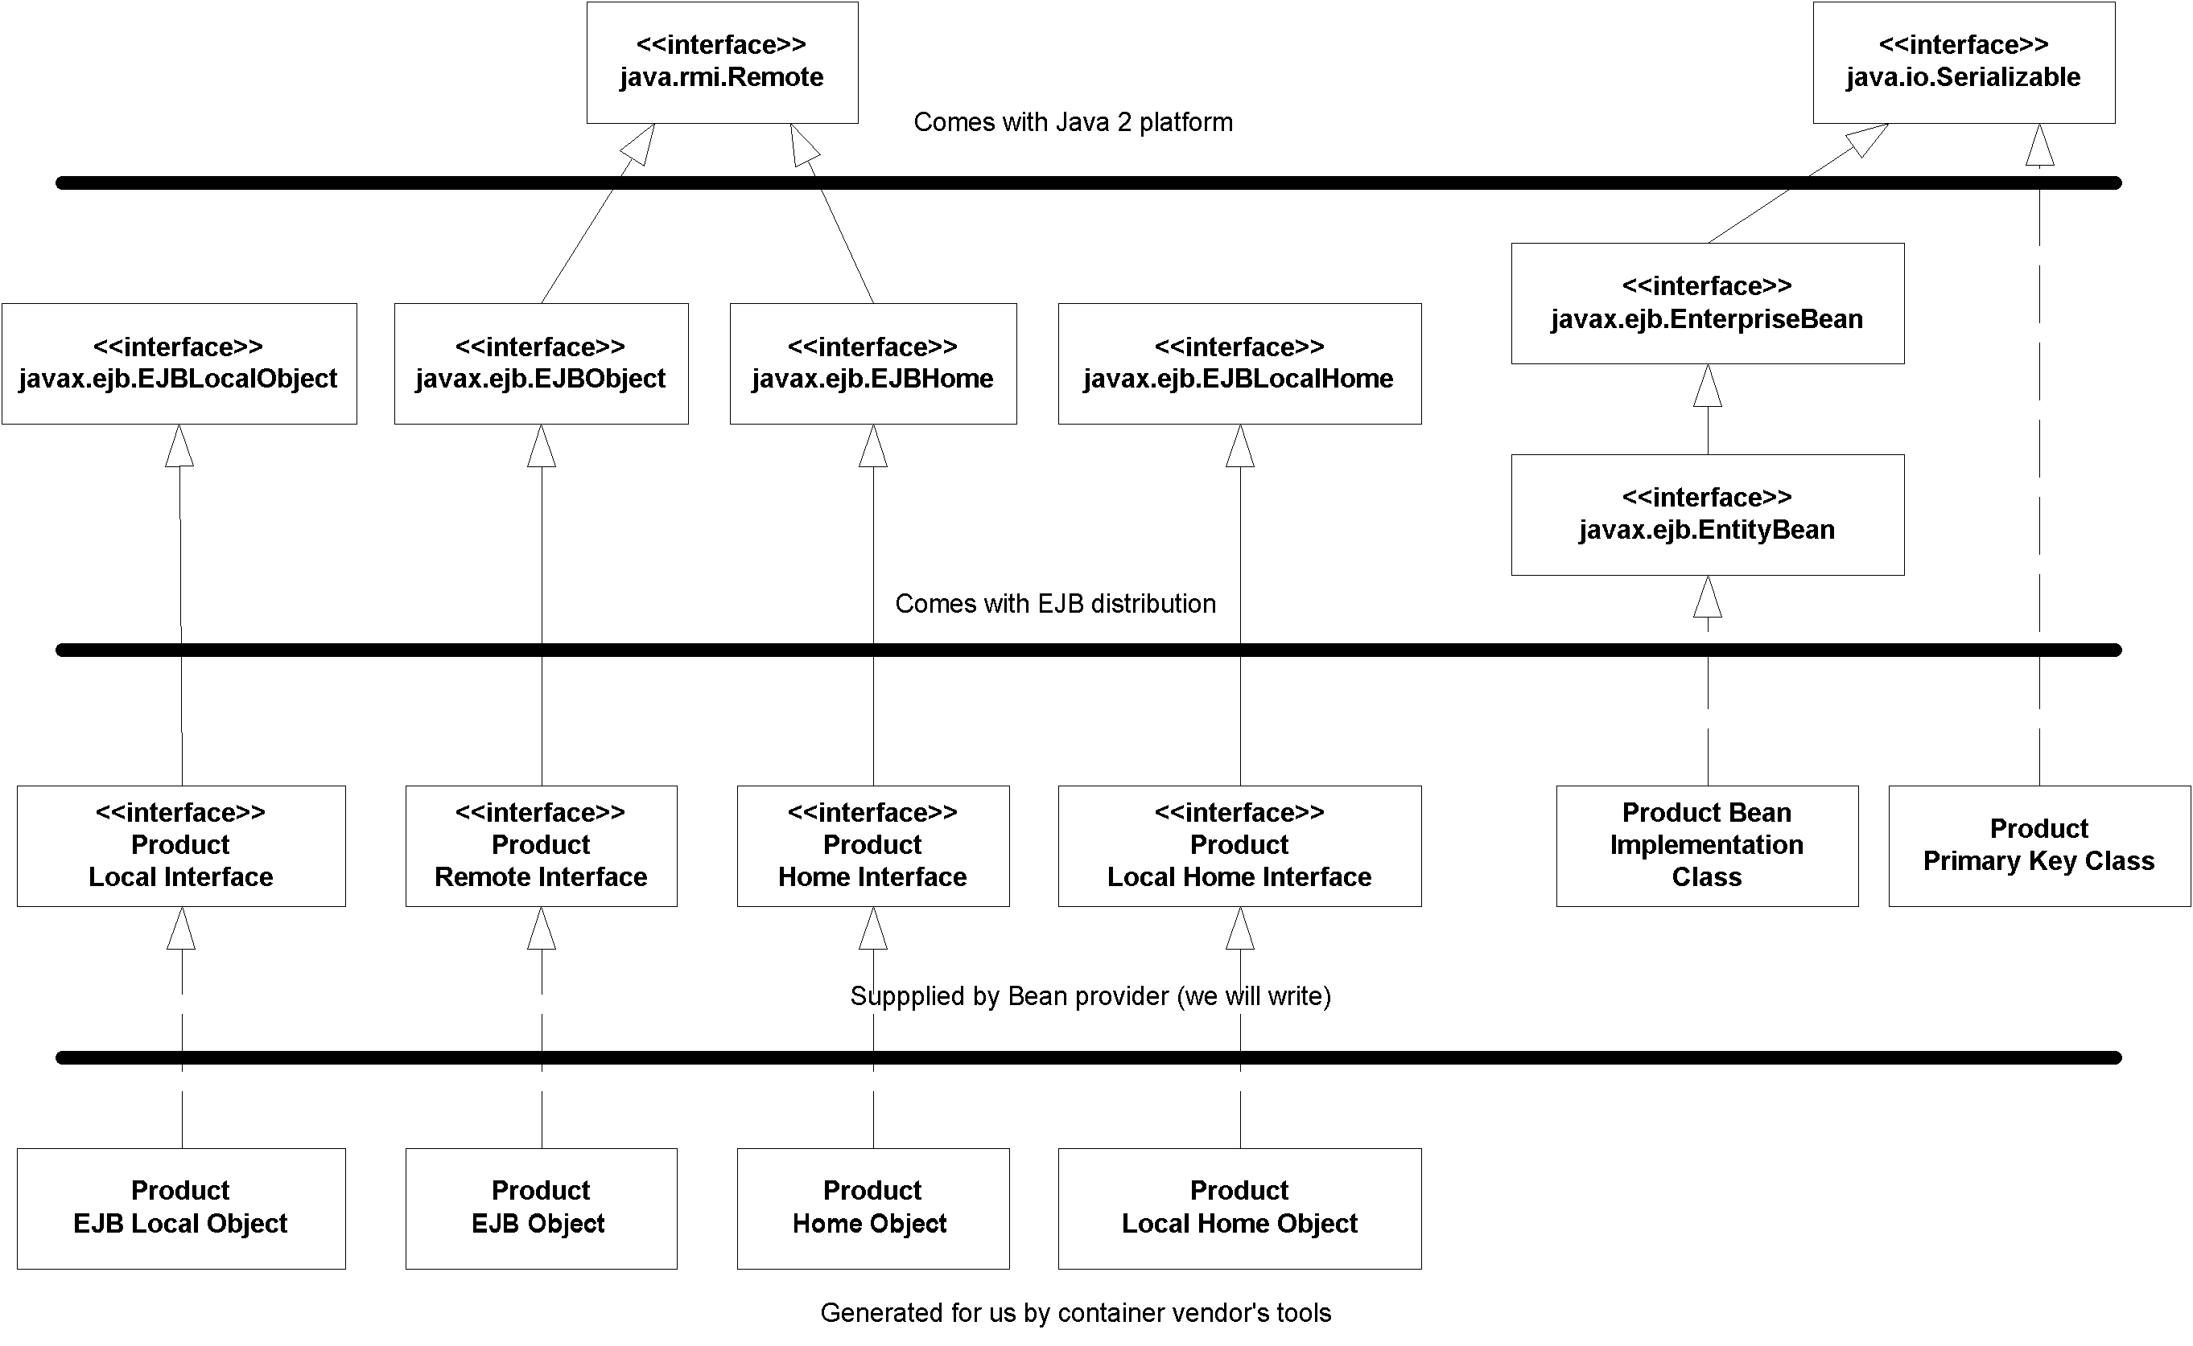
Figure X.X The object model for our product line.
Let's take a look at each of the files that we must create for our entity bean component.
Product.java
Our remote interface is what remote clients will call. The only case that a remote client should call an entity bean is when you are writing small test applications to exercise your entity bean's API, as we will do in this example. Otherwise you should use the local interface for performance reasons (see Chapter X for more on this strategy). The remote interface si shown in Source X.X.
package examples;

import javax.ejb.*;
import java.rmi.RemoteException;

/**
* These are the public business methods of ProductBean.
*
* This remote interface is what remote clients operate
* on when they interact with beans. The EJB containe
* will implement this interface; the implemented object
* is called the EJB Object, which delegates invocations
* to instances of the entity bean class.
*/
public interface Product extends EJBObject {

public String getName() throws RemoteException;
public void setName(String name) throws RemoteException;

public String getDescription() throws RemoteException;
public void setDescription(String description) throws RemoteException;

public double getBasePrice() throws RemoteException;
public void setBasePrice(double price) throws RemoteException;

public String getProductID() throws RemoteException;
}
Source X.X Product.java.
Our remote interface is quite simple. It has methods to modify the entity bean instance's fields and throws remote exceptions to indicate system-level errors.
ProductLocal.java
Our local interface is our business interface that local clients call, such as session beans or other entity beans. It's shown in Source X.X.
package examples;

import javax.ejb.*;

/**
* These are the public business methods of ProductBean.
*
* This local interface is what local clients operate
* on when they interact with our bean. The container
* will implement this interface; the implemented object
* is called the EJB local object, which delegates
* invocations to instances of the entity bean class.
*/
public interface ProductLocal extends EJBLocalObject {

public String getName();
public void setName(String name);

public String getDescription();
public void setDescription(String description);

public double getBasePrice();
public void setBasePrice(double price);

public String getProductID();
}
Source X.X ProductLocal.java
The local interface is trivially different than the remote interface. The only differences are the lack of thrown RemoteExceptions and the fact that we extend EJBLocalObject rather than EJBObject.
ProductHome.java
Next, we have the product's home interface is shown in Source X.X. As with the remote interface, this home interface should only be used by remote clients, such as a standalone application.
package examples;

import javax.ejb.*;
import java.rmi.RemoteException;
import java.util.Collection;

/**
* This is the home interface for Product. This interface
* is implemented by the EJB container. The implemented
* object is called the Home Object, and serves as a
* factory for EJB Objects.
*
* One create() method is in this Home Interface, which
* corresponds to the ejbCreate() method in the bean class.
*/
public interface ProductHome extends EJBHome {

/*
* Creates a product
*
* @param productID The number of the product (unique)
* @param name The name of the product
* @param description Product description
* @param basePrice Base Price of product
*
* @return The newly created EJB Object.
*/
Product create(String productID, String name, String description, double basePrice) throws CreateException, RemoteException;

// Finder methods. These are implemented by the
// container. You can customize the functionality of
// these methods in the deployment descriptor through
// EJB-QL and container tools.

public Product findByPrimaryKey(String key) throws FinderException, RemoteException;

public Collection findByName(String name) throws FinderException, RemoteException;

public Collection findByDescription(String description) throws FinderException, RemoteException;

public Collection findByBasePrice(double basePrice) throws FinderException, RemoteException;

public Collection findExpensiveProducts(double minPrice) throws FinderException, RemoteException;

public Collection findCheapProducts(double maxPrice) throws FinderException, RemoteException;

public Collection findAllProducts() throws FinderException, RemoteException;
}
Source X.X ProductHome.java.
Our home interface defines a single create() method to create a new product in the database. It returns a Product EJB object so the client can manipulate the entity bean data and throws a javax.ejb.CreateException to indicate an application-level problem.
We also expose all sorts of finder methods to find existing products. One of the finders returns a single EJB object, while others return a java.util.Collection of multiple EJB objects. This is needed if the finder methods find more than one matching object. Note that findByPrimaryKey() should never return a collection because primary keys must be unique.
ProductLocalHome.java
Our entity bean's local home interface is the more optimized home interface that session beans or other entity beans should use. The code is in Source X.X.
package examples;

import javax.ejb.*;
import java.util.Collection;

/**
* This is the local home interface for Product.
* This interface is implemented by the EJB container.
* The implemented object is called the local home object,
* and serves as a factory for EJB local objects.
*
* One create() method is in this Home Interface, which
* corresponds to the ejbCreate() method in the bean class.
*/
public interface ProductHome extends EJBLocalHome {

/*
* Creates a product
*
* @param productID The number of the product (unique)
* @param name The name of the product
* @param description Product description
* @param basePrice Base Price of product
*
* @return The newly created EJB Object.
*/
Product create(String productID, String name, String description, double basePrice) throws CreateException;

// Finder methods. These are implemented by the
// container. You can customize the functionality of
// these methods in the deployment descriptor through
// EJB-QL and container tools.

public Product findByPrimaryKey(ProductPK key) throws FinderException;

public Collection findByName(String name) throws FinderException;

public Collection findByDescription(String description) throws FinderException;

public Collection findByBasePrice(double basePrice) throws FinderException;

public Collection findExpensiveProducts(double minPrice) throws FinderException;

public Collection findCheapProducts(double maxPrice) throws FinderException;

public Collection findAllProducts() throws FinderException;
}
Source X.X ProductLocalHome.java
ProductPK.java
Our primary key class is defined by ProductPK.java, shown in Source X.X. This unique identifier uses a productID that could represent the product's SKU number.
package examples;

import java.io.Serializable;

/**
* Primary Key class for our 'Product' Container-Managed
* Entity Bean
*/
public class ProductPK implements java.io.Serializable {

/*
* Note that the primary key fields must be a
* subset of the the container-managed fields.
* The fields we are marking as container-managed in
* our Bean are productID, name, desc, and basePrice.
* Therefore our PK fields need to be from that set.
*/
public String productID;

public ProductPK(String productID) {
this.productID = productID;
}

public ProductPK() {}

public String toString() {
return productID.toString();
}

public int hashCode() {
return productID.hashCode();
}

public boolean equals(Object prod) {
return ((ProductPK)prod).productID.equals(productID);
}
}
Source X.X ProductPK.java.
As with bean-managed persistence, container-managed persistence dictates that your primary key class must be serializable. Because the EJB container is persisting you, it may need to query the primary key class and manipulate or compare its fields with the fields in your bean. Thus an important restriction with container-managed persistence is that the fields you have in your primary key class must come from the container-managed fields defined in your deployment descriptor.
In our example, the ProductPK class is valid because it's serializable and because it's public fields come from our container-managed fields, which we will define shortly in the deployment descriptor.
ProductBean.java
Next, we have our container-managed entity bean implementation, ProductBean.java, shown in Source X.X.
package examples;

import javax.ejb.*;

/**
* Entity Bean which demonstrates Container-Managed persistence.
*
* This is a product that's persistent. It has an ID #, a name,
* a description, and a base price.
*/
public abstract class ProductBean implements EntityBean {

protected EntityContext ctx;

public ProductBean() {
}

//-----------------------------------------------
// Begin abstract get/set methods
//-----------------------------------------------

public abstract String getName();
public abstract void setName(String name);
public abstract String getDescription();
public abstract void setDescription(String description);
public abstract double getBasePrice();
public abstract void setBasePrice(double price);
public abstract String getProductID();
public abstract void setProductID(String productID);

//-----------------------------------------------
// End abstract get/set methods
//-----------------------------------------------

//-----------------------------------------------
// Begin EJB-required methods. The methods below
// are called by the Container, and never called
// by client code.
//-----------------------------------------------

/**
* Called by Container.
* Implementation can acquire needed resources.
*/
public void ejbActivate() {
System.out.println("ejbActivate() called.");
}

/**
* EJB Container calls this method right before it
* removes the Entity Bean from the database.
* Corresponds to when client calls home.remove().
*/
public void ejbRemove() {
System.out.println("ejbRemove() called.");
}

/**
* Called by Container.
* Releases held resources for passivation.
*/
public void ejbPassivate() {
System.out.println("ejbPassivate () called.");
}

/**
* Called from the Container. Updates the entity bean
* instance to reflect the current value stored in
* the database.
*
* Since we're using Container-Managed Persistence, we
* can leave this method blank. The EJB Container will
* automatically load us in the subclass.
*/
public void ejbLoad() {
System.out.println("ejbLoad() called.");
}

/**
* Called from the Container. Updates the database to
* reflect the current values of this in-memory Entity Bean
* instance representation.
*
* Since we're using Container-Managed Persistence, we can
* leave this method blank. The EJB Container will
* automatically save us in the subclass.
*/
public void ejbStore() {
System.out.println("ejbStore() called.");
}

/**
* Called by Container. Associates this Bean instance with
* a particular context. Once done, we can query the
* Context for environment info
*/
public void setEntityContext(EntityContext ctx) {
System.out.println("setEntityContext called");
this.ctx = ctx;
}

/**
* Called by Container. Disassociates this Bean instance
* with a particular context environment.
*/
public void unsetEntityContext() {
System.out.println("unsetEntityContext called");
this.ctx = null;
}

/**
* Called after ejbCreate(). Now, the Bean can retrieve
* its EJBObject from its context, and pass it as a 'this'
* argument.
*/
public void ejbPostCreate(String productID, String name, String description, double basePrice) {
System.out.println("ejbPostCreate() called");
}

/**
* This is the initialization method that corresponds to the
* create() method in the Home Interface.
*
* When the client calls the Home Object's create() method,
* the Home Object then calls this ejbCreate() method.
*
* We need to initialize our Bean's fields with the
* parameters passed from the client, so that the Container
* can create the corresponding database entries in the
* subclass after this method completes.
*/
public String ejbCreate(String productID, String name, String description, double basePrice) {
System.out.println("ejbCreate() called");

setProductID(productID);
setName(name);
setDescription(description);
setBasePrice(basePrice);

return productID;
}

// No finder methods
// (they are implemented by Container)

//-----------------------------------------------
// End EJB-required methods
//-----------------------------------------------
}
Source X.X ProductBean.java.
This bean is more complex than our bank account example. We've defined many finder methods, and we have more persistent fields. Yet even though we've added all this complexity, our bean is less than 40 percent of the size of our Bank Account bean. This is an amazing reduction in code complexity. And because our bean has no database code in it, we have reduced the chance for bugs in our bean that would be due to user error working with JDBC code. This is a huge savings in development and testing time.
We do not have any fields, since the container will declare them in the subclass. We have a few abstract get/set methods, which the container will also implement in the subclass. The only really interesting method is ejbCreate() which takes the parameters passed in from the client and calls the bean's own abstract set() methods to populate the bean with the initialization data. The container will then perform a SQL INSERT in the subclass once ejbCreate() concludes.
The rest of our bean is just empty EJB-required methods and comments. In fact, if we took the comments, whitespace, and println's out, the bean would just be this:
package examples;
import javax.ejb.*;

public abstract class ProductBean implements EntityBean {
protected EntityContext ctx;

public abstract String getName();
public abstract void setName(String name);
public abstract String getDescription();
public abstract void setDescription(String description);
public abstract double getBasePrice();
public abstract void setBasePrice(double price);
public abstract String getProductID();
public abstract void setProductID(String productID);

public void ejbActivate() {}
public void ejbRemove() {}
public void ejbPassivate() {}
public void ejbLoad() {}
public void ejbStore() {}
public void setEntityContext(EntityContext ctx) {
this.ctx = ctx;
}
public void unsetEntityContext() { this.ctx = null; }

public void ejbPostCreate(String productID, String name, String description, double basePrice) {}

public String ejbCreate(String productID, String name, String description, double basePrice) {
setProductID(productID);
setName(name);
setDescription(description);
setBasePrice(basePrice);
return productID;
}
}
The Deployment Descriptor
We now need to inform our container about our entity bean, such as our container-managed fields and our EJB-QL. The deployment descriptor is shown in Source X.X.
<?xml version="1.0"?>

<!DOCTYPE ejb-jar PUBLIC "-//Sun Microsystems, Inc.//DTD Enterprise JavaBeans 2.0//EN" "http://java.sun.com/j2ee/dtds/ejb-jar_2_0.dtd">

<ejb-jar>
<enterprise-beans>
<entity>
<ejb-name>Product</ejb-name>
<home>examples.ProductHome</home>
<remote>examples.Product</remote>
<local-home>examples.ProductLocalHome</local-home>
<local>examples.ProductLocal</local>
<ejb-class>examples.ProductBean</ejb-class>
<persistence-type>Container</persistence-type>
<prim-key-class>examples.ProductPK</prim-key-class>

<reentrant>False</reentrant>

<cmp-version>2.x</cmp-version>
<abstract-schema-name>ProductBean</abstract-schema-name>

<cmp-field>
<field-name>productID</field-name>
</cmp-field>
<cmp-field>
<field-name>name</field-name>
</cmp-field>
<cmp-field>
<field-name>description</field-name>
</cmp-field>
<cmp-field>
<field-name>basePrice</field-name>
</cmp-field>

<query>
<query-method>

<method-name>findByName</method-name>
<method-params>
<method-param>java.lang.String</method-param>
</method-params>
</query-method>
<ejb-ql>
<![CDATA[SELECT OBJECT(a) FROM ProductBean AS a WHERE name = ?1]]>
</ejb-ql>
</query>

<query>
<query-method>
<method-name>findByDescription</method-name>
<method-params>
<method-param>java.lang.String</method-param>
</method-params>
</query-method>
<ejb-ql>
<![CDATA[SELECT OBJECT(a) FROM ProductBean AS a WHERE description = ?1]]>
</ejb-ql>
</query>

<query>
<query-method>
<method-name>findByBasePrice</method-name>
<method-params>
<method-param>double</method-param>
</method-params>
</query-method>
<ejb-ql>
<![CDATA[SELECT OBJECT(a) FROM ProductBean AS a WHERE basePrice = ?1]]>
</ejb-ql>
</query>

<query>
<query-method>
<method-name>findExpensiveProducts</method-name>
<method-params>
<method-param>double</method-param>
</method-params>
</query-method>
<ejb-ql>
<![CDATA[SELECT OBJECT(a) FROM ProductBean AS a WHERE basePrice > ?1]]>
</ejb-ql>
</query>

<query>
<query-method>
<method-name>findCheapProducts</method-name>
<method-params>
<method-param>double</method-param>
</method-params>
</query-method>
<ejb-ql>
<![CDATA[SELECT OBJECT(a) FROM ProductBean AS a WHERE basePrice < ?1]]>
</ejb-ql>
</query>

<query>
<query-method>
<method-name>findAllProducts</method-name>
<method-params>
</method-params>
</query-method>
<ejb-ql>
<![CDATA[SELECT OBJECT(a) FROM ProductBean AS a WHERE productID IS NOT NULL]]>
</ejb-ql>
</query>

</entity>
</enterprise-beans>

<assembly-descriptor>
<container-transaction>
<method>
<ejb-name>Product</ejb-name>
<method-intf>Remote</method-intf>
<method-name>*</method-name>
</method>
<trans-attribute>Required</trans-attribute>
</container-transaction>
</assembly-descriptor>

</ejb-jar>
Source X.X ejb-jar.xml
Our deployment descriptor begins by identifying the name of the bean, then bean class, and so-on, which is the same as bean-managed persistence. We then go on to define the container-managed fields, which must match the abstract get/set methods in the enterprise bean class.
The bulk of the descriptor following this is the code for our queries. For example, the findExpensiveProducts() finder method locates all products that are more expensive than the double parameter passed in. To instruct the container on how to implement this finder functionality, we define our EJB-QL as follows:
<![CDATA[SELECT OBJECT(a) FROM ProductBean AS a WHERE basePrice > ?1]]>
When the container interprets this EJB-QL, it will generate database access code (such as JDBC) to find all of the expensive products whose basePrice column is greater in value than the double passed in, represented by the ?1. Then whenever a client wants to execute a finder method on the home object, the container will automatically run the database access code.
Notice also the word "CDATA". This instructs the container's XML parser to ignore the text "SELECT OBJECT(a) FROM ProductBean AS a WHERE basePrice > ?1". This is important because the container's XML parser may think that the text inside the CDATA section does not comply with the XML standard because it may think the > character is actually the closing of an XML tag, rather than a less-than sign. Thus all EJB-QL must be enclosed in CDATA sections.
The end of our descriptor associates transactions with our entity bean, which we'll learn about in Chapter X.
When to use custom primary key classes
In our bean, we've declared a custom primary key class, ProductPK. We then have this element in our deployment descriptor:@@@COMP: Code within the SBT@@@
<prim-key-class>examples.ProductPK</prim-key-class>
However, this is not strictly necessary. If you'd like, you can choose not to invent a custom primary key class, and just use one of your container-managed fields as the primary key. For example, we could use the productID String field as the primary key, rather than wrapping it in another primary key wrapper class. Then we would declare the primary key class to be a java.lang.String, and we would have this element after we declare the container-managed fields:@@@COMP: Code within the SBT@@@
<primkey-field>productID</primkey-field>
So when should use use a custom primary key class, and when should you use one of your fields? In our opinion, you should avoid using your own fields as primary key classes. The reason is because having a primary key class wrapper isolates you from changes to how you'd like to be uniquely represented in an underlying storage. By having a primary key class wrapper, it is much easier to change how you'd like to be uniquely identified without breaking code.
The Container-Specific Deployment Descriptor
In addition to the deployment descriptor, we need to tell the container exactly how to perform persistent operations. This is one trade-off of container-managed persistence—you still need to declare persistent rules, rather than code them into your bean using JDBC or SQL/J.
If you're using a relational data store, you'll need to define exactly how your entity bean's public fields map to that database. Thus, we must define a series of object-relational mapping entries. These entries map entity bean fields to relational database column names. The EJB container will use this mapping when storing or retrieving our container-managed fields from the database. Note that this is very EJB container-specific! Some EJB containers will support object databases and thus will not have a mapping into a two-dimensional relational database. Consult your EJB container's documentation for more information. Our product line's persistent entries for a relational database are shown in Table X.X. See the book's accompanying source-code for the actual descriptor.
Table X.X Sample Persistent Settings for ProductBean
Object/Relational Setting
(entity bean field = relational column name)
productID=id
name=name
description=description
basePrice=basePrice
Client.java
Our client code is a simple suite of test cases to try out our bean, as shown Source X.X.
package examples;

import javax.ejb.*;
import javax.naming.*;
import java.rmi.*;
import javax.rmi.PortableRemoteObject;
import java.util.*;

/**
* Client test application on a CMP Entity Bean, Product.
*/
public class ProductClient {

public static void main(String[] args) throws Exception {

ProductHome home = null;

try {
/*
* Get a reference to the Product Home Object - the
* factory for Product EJB Objects
*/
Context ctx = new InitialContext(System.getProperties());
home = (ProductHome) PortableRemoteObject.narrow(
ctx.lookup("ProductHome"), ProductHome.class);

/*
* Use the factory to create the Product EJB Object
*/
home.create("123-456-7890", "P5-350", "350 Mhz Pentium", 200);
home.create("123-456-7891", "P5-400", "400 Mhz Pentium", 300);
home.create("123-456-7892", "P5-450", "450 Mhz Pentium", 400);
home.create("123-456-7893", "SD-64", "64 MB SDRAM", 50);
home.create("123-456-7894", "SD-128", "128 MB SDRAM", 100);
home.create("123-456-7895", "SD-256", "256 MB SDRAM", 200);

/*
* Find a Product, and print out it's description
*/
Iterator i = home.findByName("SD-64").iterator();
System.out.println("These products match the name SD-64:");
while (i.hasNext()) {
Product prod = (Product) PortableRemoteObject.narrow(
i.next(), Product.class);
System.out.println(prod.getDescription());
}

/*
* Find all products that cost $200
*/
System.out.println("Finding all products that cost $200");
i = home.findByBasePrice(200).iterator();

while (i.hasNext()) {
Product prod = (Product) PortableRemoteObject.narrow(
i.next(), Product.class);
System.out.println(prod.getDescription());
}
}
catch (Exception e) {
e.printStackTrace();
}
finally {
if (home != null) {
System.out.println("Destroying products..");

/*
* Find all the products
*/
Iterator i = home.findAllProducts().iterator();
while (i.hasNext()) {
try {
Product prod = (Product) PortableRemoteObject.narrow(
i.next(), Product.class);
if (prod.getProductID().startsWith("123")) {
prod.remove();
}
}
catch (Exception e) {
e.printStackTrace();
}
}
}
}
}
}
Source X.X Client.java.
Because this standalone application runs in a separate process from the application server, for testing purposes this client calls through the bean's remote interface, rather than local interface. However, in a real-world scenario, we would be wrapping this entity bean with a session bean and calling through its local interface.
The client performs a JNDI lookup to acquire the home object and create some entity bean data. We then try out a couple of finder methods. We can loop through the finders' returned numerations and call business methods on each EJB object. We then destroy all the EJB objects we created in a finally{} clause.
Running the Client Program
To run the client program, type a command similar to the following (depending on what your EJB container Java Naming and Directory Interface, orJNDI, initialization parameters are):
java -D java.naming.factory.initial=weblogic.jndi.WLInitialContextFactory -Djava.naming.provider.url=t3://localhost:7001 examples.ProductClient
The initialization parameters are required by JNDI to find the home object, as we learned in Chapter X.
When we run the client, we first create a few products, and then we we performed a find for all products that cost $200. Indeed, multiple entity beans were returned in our collection, as is shown below:
These products match the name SD-64:
64 MB SDRAM
Finding all products that cost $200
USB Speaker System
350 Mhz Pentium
256 MB SDRAM
Destroying products..
The Lifecycle of a CMP entity bean
Now that we've seen a complete CMP entity bean example, let's fully understand how the container interacts with CMP entity beans. Figure X.X shows this.
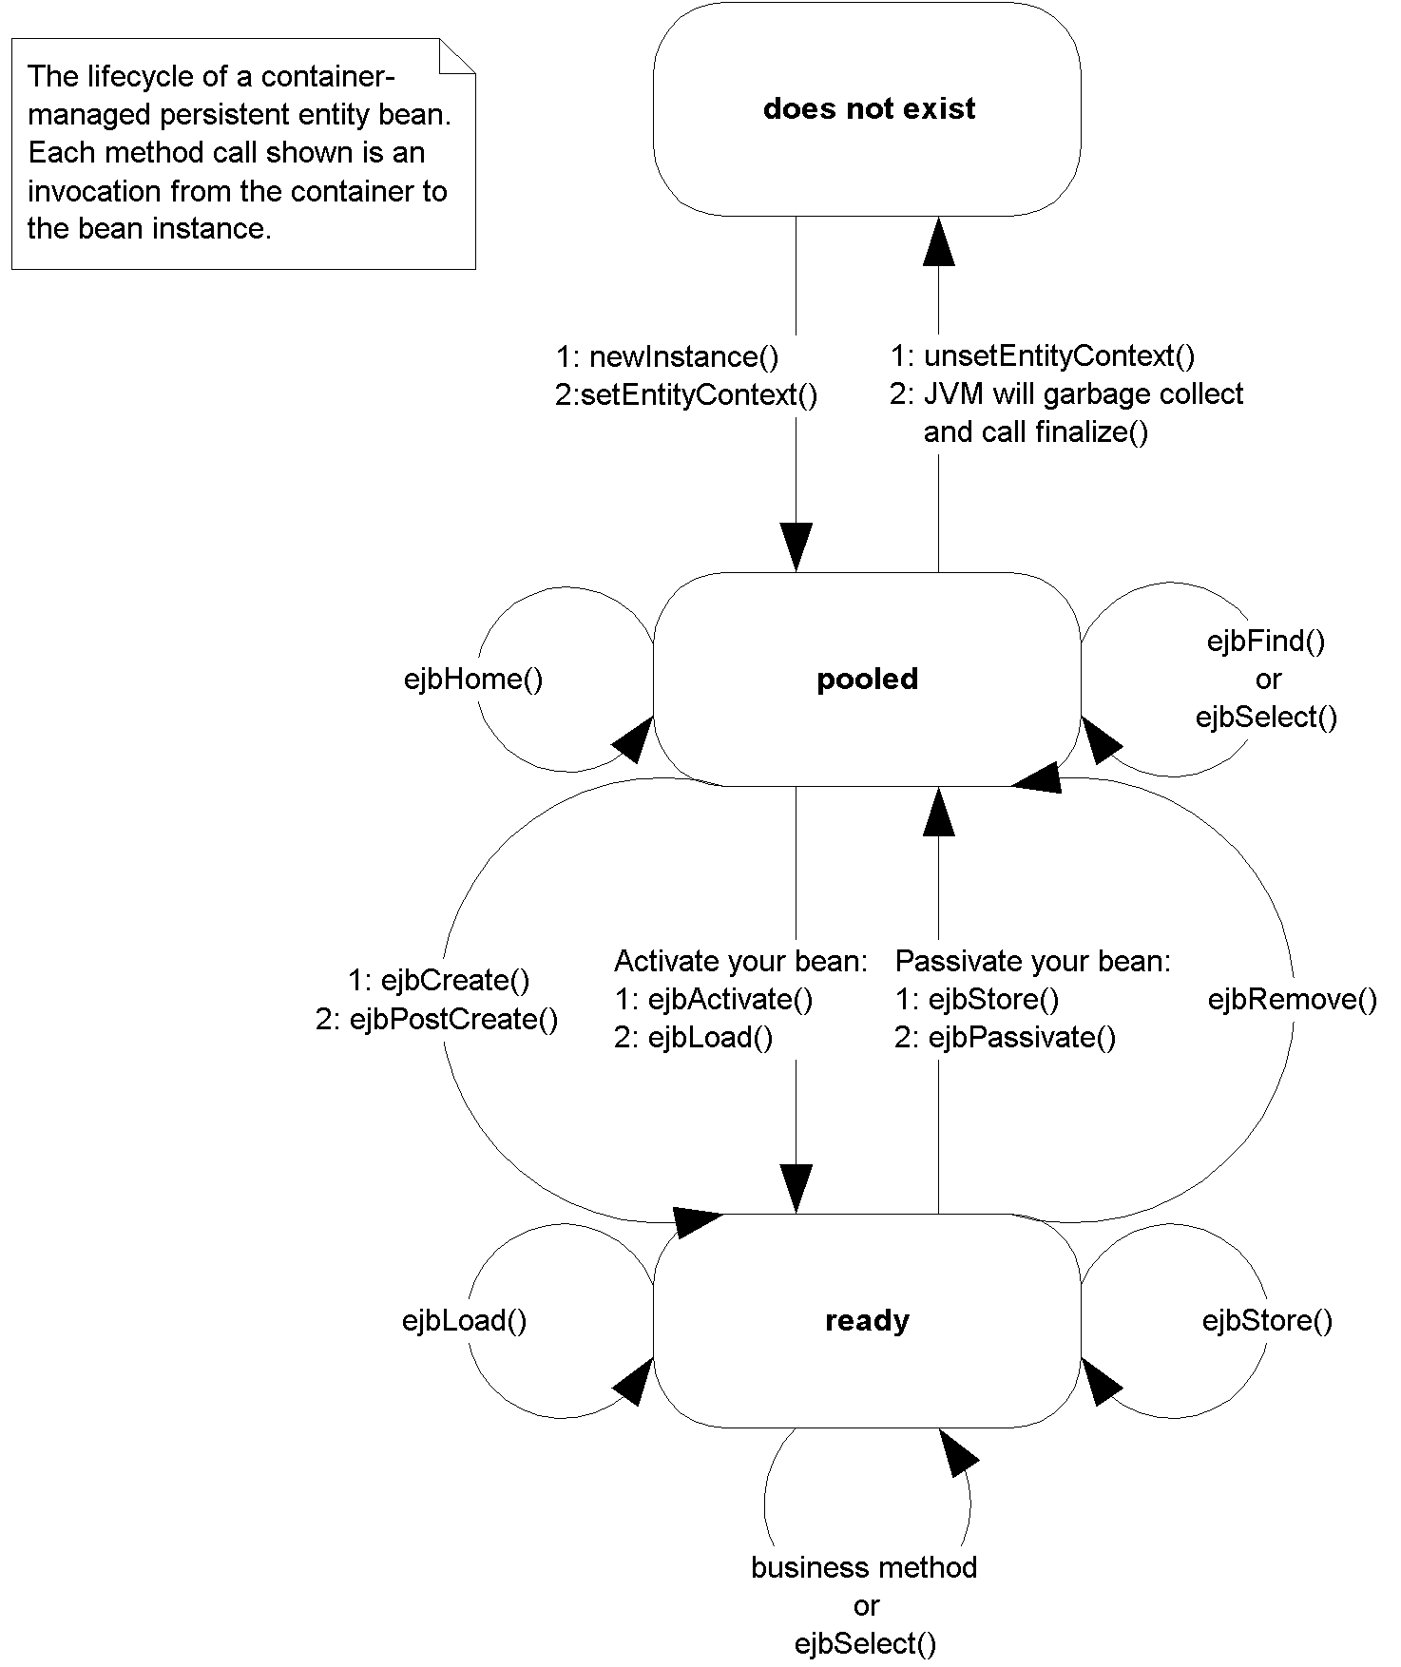
Figure X.X The CMP entity bean lifecycle
The lifecycle of a CMP entity bean is exactly the same as that for a BMP entity bean, which we fully described at the end of the previous chapter (refer back if you need to refresh your memory). The only differences are that ejbSelect() methods can be called from the pooled state or ready state.
Summary
In this chapter, you learned how to write container-managed persistent entity beans. We saw how the bean instance callback methods differ between bean-managed persistence and container-managed persistence. We then went through an example modeling product line. Finally, we wrapped up with a look at the lifecycle of a CMP entity bean.

